

*Project Report*

**Department of Computer Science and Engineering**

**Course Code:** CSE435

**Course Title:** Software Quality Assurance

**Semester:** FALL 2018

**Submitted To:** Shakila Mahjabin Tonni

Lecturer, Department of CSE

**Submitted By : Pritam Chowdhury**

**Date of submission:** 17 December, 2018

**Project Name:** Student Information

**Project View:**

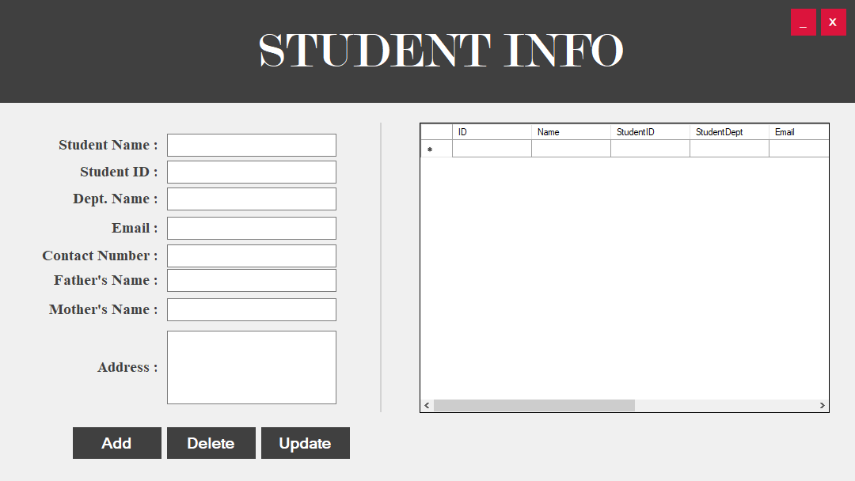

**Figure 01: First view of the project**

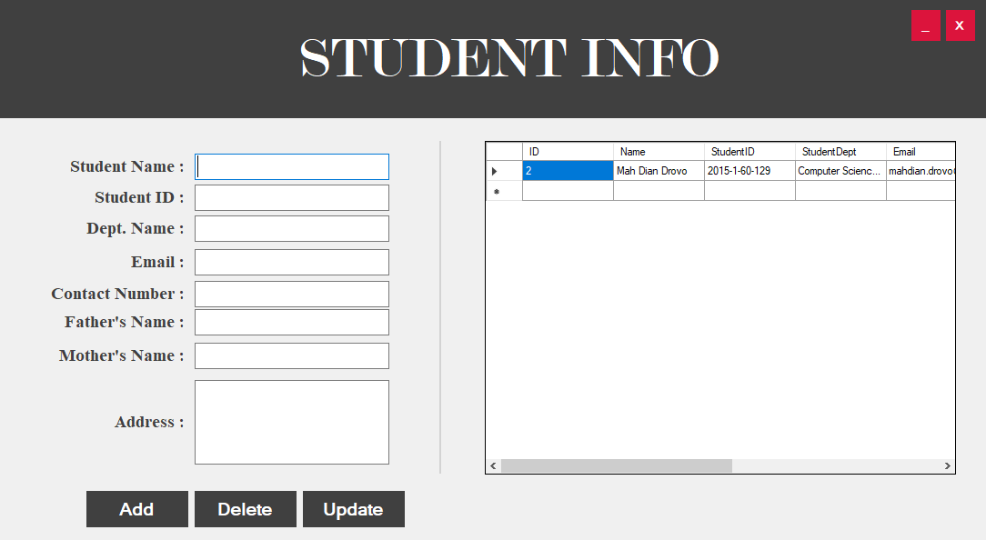

**Figure 02:** After Inserting Data



**Figure 03:** After Delete the Data

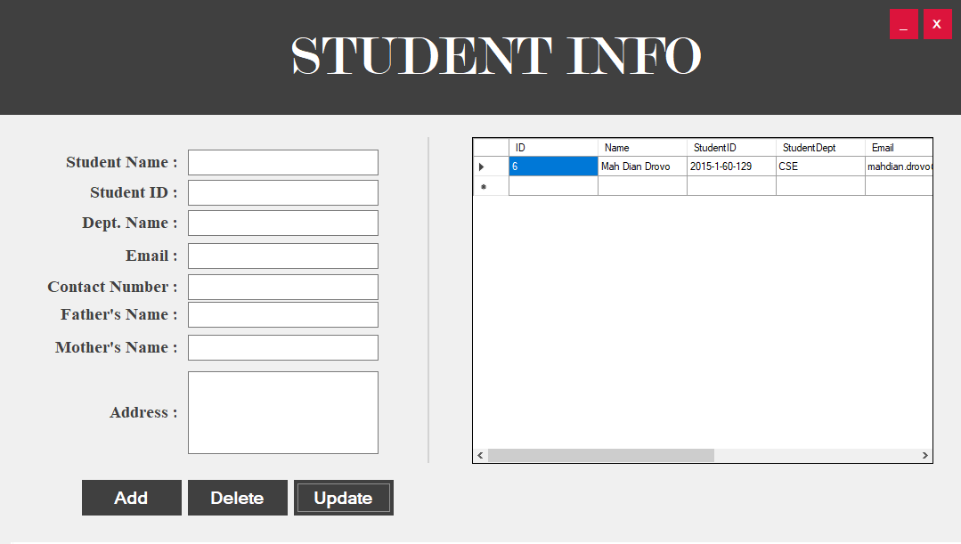

**Figure 04:** After edit the same data inserted again

**Test Case Design:**

Test Case 1: Insert Data by providing only 3 data

|  |  |  |  |  |  |
| --- | --- | --- | --- | --- | --- |
| Step | Test Steps | Test Data | Expected Results | Actual Result | Status (Pass/Fail) |
| 1 | Insert Student name, Student ID, Dept. Name and other values will be empty. | 1. Khan   123  CSE | Data will be added into the database | Added to the database | Pass |
| 2 | Click “Add” |

Test Case 2: Insert Data by providing 4 data

|  |  |  |  |  |  |
| --- | --- | --- | --- | --- | --- |
| Step | Test Steps | Test Data | Expected Results | Actual Result | Status (Pass/Fail) |
| 1 | Insert Student name, Student ID, Dept. Name,Email and other values will be empty. | 1. Khan   123  CSE  akhan@mail.com | Data will be added into the database | Added to the database | Pass |
| 2 | Click “Add” |

Test Case 3: Insert Data by providing invalid mail (akhan@m.com)

|  |  |  |  |  |  |
| --- | --- | --- | --- | --- | --- |
| Step | Test Steps | Test Data | Expected Results | Actual Result | Status (Pass/Fail) |
| 1 | Insert the wrong mail | 1. Khan   123  CSE  akhan@m.com | There should be exception error there. | Exception error | Pass |
| 2 | Click “Add” |

Test Case 4: Insert ID as Null

|  |  |  |  |  |  |
| --- | --- | --- | --- | --- | --- |
| Step | Test Steps | Test Data | Expected Results | Actual Result | Status (Pass/Fail) |
| 1 | Insert ID as null and others will be correct values | 1. Khan   NULL  CSE  akhan@mail.com | There should be exception error there. | Exception error | Pass |
| 2 | Click “Add” |

Test Case 5: Insert Data by providing every correct values

|  |  |  |  |  |  |
| --- | --- | --- | --- | --- | --- |
| Step | Test Steps | Test Data | Expected Results | Actual Result | Status (Pass/Fail) |
| 1 | Insert all correct values | 1. Khan   123  CSE  akhan@gmail.com  777888  X. Khan  Y. Khanom  Bdesh | This record should be added. | Added | Pass |
| 2 | Click “Add” |

Test Case 6: Insert first Student name and Student ID as NULL

|  |  |  |  |  |  |
| --- | --- | --- | --- | --- | --- |
| Step | Test Steps | Test Data | Expected Results | Actual Result | Status (Pass/Fail) |
| 1 | Insert all correct values | NULL  NULL  123  CSE  akhan@gmail.com  NULL  NULL… … | There should be Null reference exception | Got the exception | Pass |
| 2 | Click “Add” |

Test Case 7: Insert every values NULL

|  |  |  |  |  |  |
| --- | --- | --- | --- | --- | --- |
| Step | Test Steps | Test Data | Expected Results | Actual Result | Status (Pass/Fail) |
| 1 | Insert every values Null | Null  Null  … … | This record should be added. | Added | Pass |
| 2 | Click “Add” |

Test Case 8: Delete a data

|  |  |  |  |  |  |
| --- | --- | --- | --- | --- | --- |
| Step | Test Steps | Test Data | Expected Results | Actual Result | Status (Pass/Fail) |
| 1 | Click over the delete data |  | The data should be deleted | Deleted | Pass |
| 2 | Click “Delete” |

Test Case 9: Delete a Null data

|  |  |  |  |  |  |
| --- | --- | --- | --- | --- | --- |
| Step | Test Steps | Test Data | Expected Results | Actual Result | Status (Pass/Fail) |
| 1 | Click over the delete data |  | There is no data. So no data will be deleted | No data deleted | Pass |
| 2 | Click “Delete” |

Test Case 10: Update a data

|  |  |  |  |  |  |
| --- | --- | --- | --- | --- | --- |
| Step | Test Steps | Test Data | Expected Results | Actual Result | Status (Pass/Fail) |
| 1 | Click on a data to be updated | ID 7788 to 123 | Data should be updated | Data is Updated | Pass |
| 2 | Enter the Updated data |
| 3 | Click “Update” |

Test Case 11: Update a data by providing NULL

|  |  |  |  |  |  |
| --- | --- | --- | --- | --- | --- |
| Step | Test Steps | Test Data | Expected Results | Actual Result | Status (Pass/Fail) |
| 1 | Click on a data to be updated | Address : “NULL” | Data should be updated | Data is Updated | Pass |
| 2 | Enter the Updated data |
| 3 | Click “Update” |

Test Case 12: Update a data by providing name as NULL

|  |  |  |  |  |  |
| --- | --- | --- | --- | --- | --- |
| Step | Test Steps | Test Data | Expected Results | Actual Result | Status (Pass/Fail) |
| 1 | Click on a data to be updated | Name : “NULL” | Data should not be updated | Data is not Updated | Pass |
| 2 | Enter the Updated data |
| 3 | Click “Update” |

Test Case 13: Update a data by providing ID as NULL

|  |  |  |  |  |  |
| --- | --- | --- | --- | --- | --- |
| Step | Test Steps | Test Data | Expected Results | Actual Result | Status (Pass/Fail) |
| 1 | Click on a data to be updated | ID : “NULL” | Data should not be updated | Data is not Updated | Pass |
| 2 | Enter the Updated data |
| 3 | Click “Update” |

Test Case 14: Update a data by providing Dept. Name as NULL

|  |  |  |  |  |  |
| --- | --- | --- | --- | --- | --- |
| Step | Test Steps | Test Data | Expected Results | Actual Result | Status (Pass/Fail) |
| 1 | Click on a data to be updated | Dept. Name : “NULL” | Data should not be updated | Data is not Updated | Pass |
| 2 | Enter the Updated data |
| 3 | Click “Update” |

Test Case 15: Test the connection

|  |  |  |  |  |  |
| --- | --- | --- | --- | --- | --- |
| Step | Test Steps | Test Data | Expected Results | Actual Result | Status (Pass/Fail) |
| 1 | Check for false connection |  | Connection should failed | Failed | Pass |

**Conclusion:** Here we have checked our modules properly and got the Test result.